**Teachers Panel**

1. **Name:** Sibi M

**Designation:** Project Head

**Qualification:** B-Tech Computer Science

**Subject**: Mathematics.



1. **Name:** Maneesh PU

**Designation**: Project Head

**Qualification:** MPhil (commerce), Mcom, BPED, PGDCA

**Subject:** Accountancy

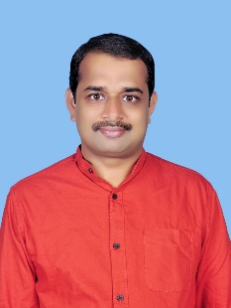

1. **Name**: Bibin Mathew

**Designation:** Faculty

**Qualification:**  BA Economics, MA Economics, MBA HR and Marketing

**Subject:** Business studies, Economics

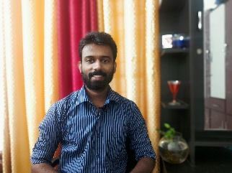

1. **Name**: Thomas P John

**Designation:** Faculty

**Qualification:**  MSc; BEd

**Subject:** Mathematics

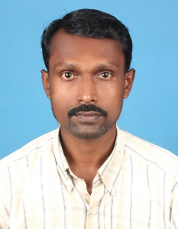

1. **Name**: Hetal Pradeep

**Designation:** Faculty

**Qualification:**  MCA

**Subject:** Mathematics

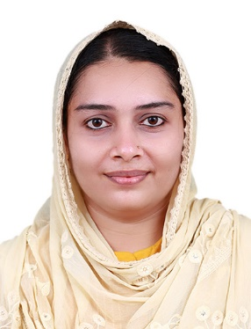

1. **Name**: Rita Jane EM

**Designation:** Faculty

**Qualification:**  M.A.English

**Subject:** English

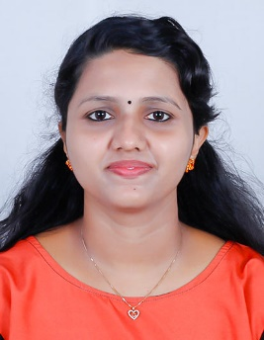

1. **Name**: SHYLAJA DEVI T. R

**Designation:** Faculty

**Qualification:**  MA, Bed

**Subject:** English

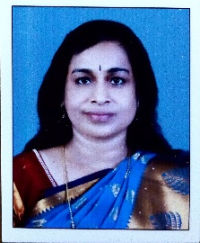

1. **Name**: Tessy Jose C

**Designation:** Faculty

**Qualification:**  MA, BEd

**Subject:** English

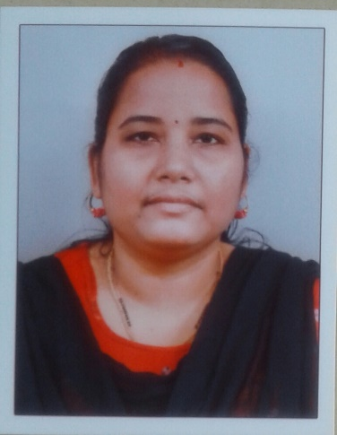

1. **Name**:  Raka VK

**Designation:** Faculty

**Qualification:**  MSc Chemistry with BEd and SET

**Subject:** Chemistry

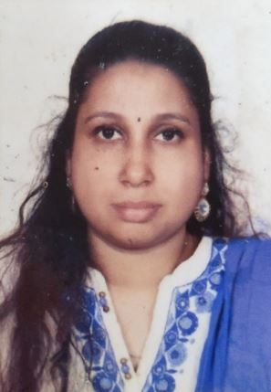

1. **Name**:  Remya Roy

**Designation:** Faculty

**Qualification:**  MSc

**Subject:** Biology

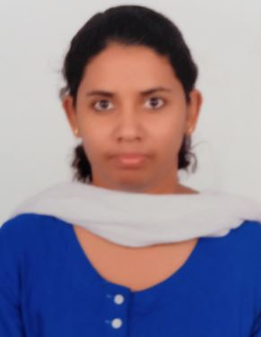

1. **Name**:  Athira PK

**Designation:** Faculty

**Qualification:**   MA

**Subject:** Hindi

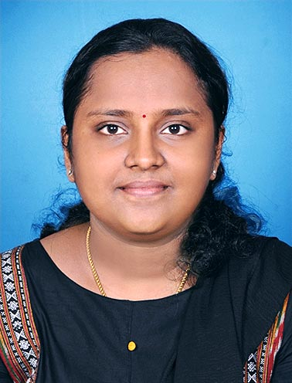

1. **Name**:  Sangeetha S

**Designation:** Faculty

**Qualification:**   M Tech

**Subject:** Physics

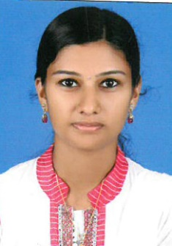

1. **Name**: Aishwarya

**Designation:** Faculty

**Qualification:** MSc BEd

**Subject:** Biology

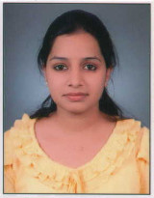

1. **Name**: Sumeera Sreejesh

**Designation:** Faculty

**Qualification:** MSc. Mathematics, B Ed.

**Subject:** Maths

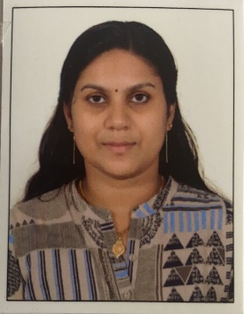

1. **Name**: Hemanth S

**Designation:** Faculty

**Qualification:** MSc,  BEd.

**Subject:** Chemistry



1. **Name**: MYTHILI KAILAS

**Designation:** Faculty

**Qualification:** MSc,MPhil in physics.

**Subject:** Physics

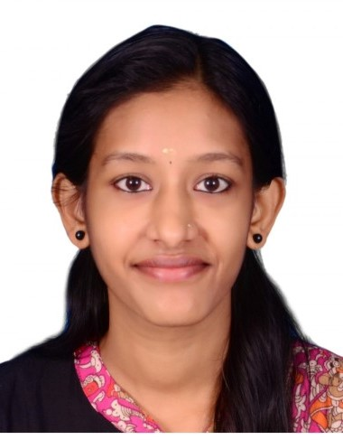

1. **Name**: NISHAMOL V M

**Designation:** Faculty

**Qualification:** MSc Bed (Physics)

**Subject:** Mathematics

